PRACTICE 5
- Write a query for the HR department to produce the addresses of all the departments. Use the LOCATIONS and COUNTRIES tables. Show the location ID, street address, city, state or province, and country in the output. Use a NATURAL JOIN to produce the results.

SELECT LOCATION_ID , STREET_ADDRESS , CITY , STATE_PROVINCE,COUNTRY_NAME FROM LOCATIONS NATURAL JOIN COUNTRIES;

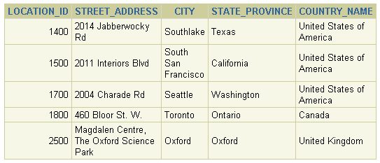
- The HR department needs a report of all employees. Write a query to display the last name, department number, and department name for all employees.

SELECT EMPLOYEES.LAST_NAME,DEPARTMENT_ID,DEPARTMENTS.DEPARTMENT_NAME FROM EMPLOYEES JOIN DEPARTMENTS USING (DEPARTMENT_ID);
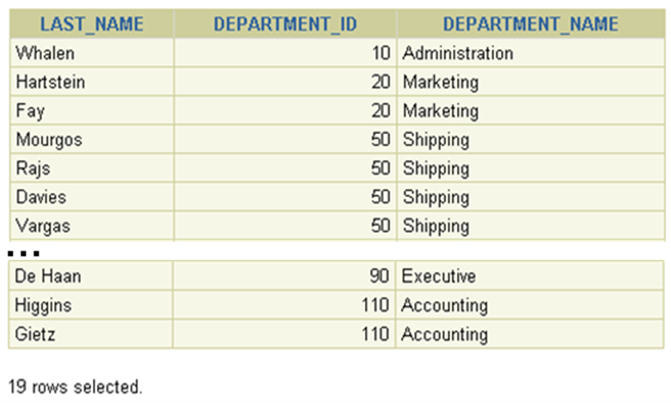
- The HR department needs a report of employees in Toronto. Display the last name, job, department number, and department name for all employees who work in Toronto.

select e.last_name,e.job_id,d.department_id,d.department_name
from employees e join departments d
on e.department_id=d.department_id join locations l on d.location_id=l.location_id
and l.city='Toronto'

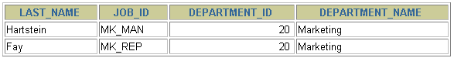
- Create a report to display employees’ last name and employee number along with their manager’s last name and manager number. Label the columns Employee, Emp#, Manager, and Mgr#, respectively.

select e.last_name,e.employee_id as "EMP#",m.last_name,m.manager_id as "MGR#"
from employees e join employees m
on e.manager_id=m.employee_id
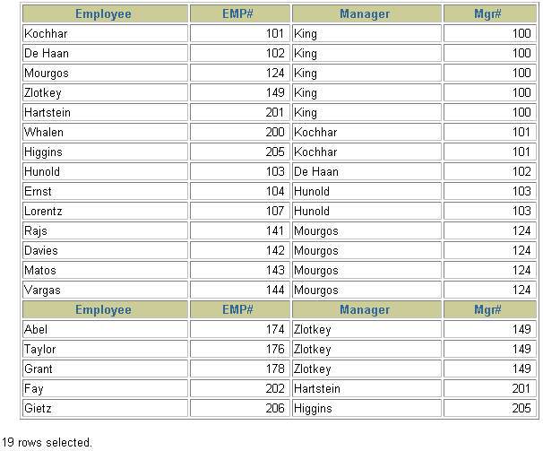
Practice 5 (continued)
- Modify lab_05 to display all employees including King, who has no manager. Order the results by the employee number.

select e.last_name,e.employee_id as "EMP#",m.last_name,m.manager_id as "MGR#"
from employees e left outer join employees m
on e.manager_id=m.employee_id
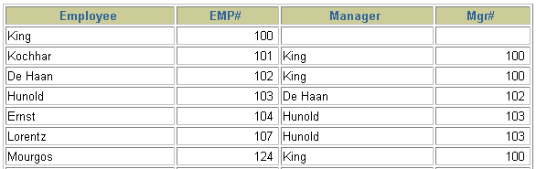
- Create a report for the HR department that displays employee last names, department numbers, and all the employees who work in the same department as a given employee. Give each column an appropriate label.

select e.last_name ,f.last_name,d.department_id from employees e join employees f
on e.department_id=f.department_id join departments d on e.department_id=d.department_id
